the simpsons

Final Assignment

dec 8, 2021

# Amanda Delisle

## DGL123 PHP: instructor Brad best

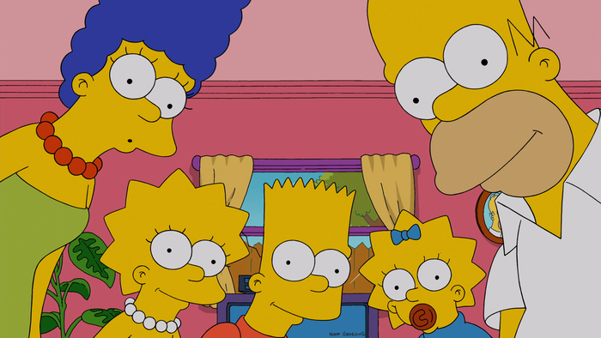

**Project Summary**

The idea of making a website from scratch was exciting and intimidating. I found that it did take me a while to code it, even though we did copy the html, and then it still took me a bit to clue into the fact that I could copy the CSS. So that did make this a million times easier than I thought it was going to be, coding all the CSS from scratch!

I didn’t really understand the fact that we were supposed to use a database and employ the use of mysql until today. I feel like me there was a lot of miss communication and I certainly did not get the direction or support I needed to complete this assignment to my best ability.

I handled the hurdles by searching online, taking tutorials, reading the text, reaching out on slack and email. Then a TON of trial and error. I kept the name of the file as you can see it was my final last try to get this to work, and I made a lot of progress from where I was convinced I would totally fail this until about 3pm today.

The remaining issues with my code are at this point anyways of writing this, that all the character cards and info are on the bottom of the website in one long row. I could not figure out how to properly use isset($_GET[‘checkbox’]) I did a lot of combo’s and nothing to this point has worked. So that is really too bad, as I am sure someone could have easily helped me get on track and then I would have been able to see if the styling on the cards is correctly showing up when only one was selected and not in a big row. I do know that they are separate cards though from messing around with it.

The second issue with the code is that I could not figure out how to properly use if(!empty($variable_name???){} function to ask the computer to not fetch the empty row/column for Maggie and Moe on occupations/voicedBy. I did notice this and try though was unsuccessful.

If I were to keep working on it, and improve the project I would like to have help to fix all the wrong things. I like the layout, I probably would not change that at all. If I were going to go for the website of characters, I would add a nav bar and have this as only one page. I might change background color on the cards. I noticed it was already responsive.

I would also obviously delete the files and clean up the code a lot, erasing all mistakes and wrong code. I want to leave it in as so you can see my line of thinking and what I tried over the days working on this. Especially since I didn’t know soon enough about the database and spent a lot of time on arrays/loops.